­­­

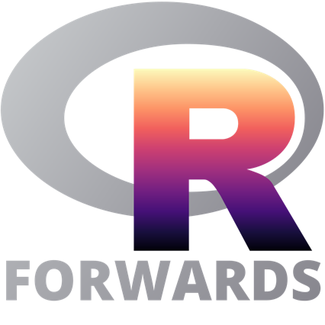

invites high school girls

in the NYC area to apply to:

**Data Science in R: Navigating NYC**

Free Coding Workshop for High School Girls

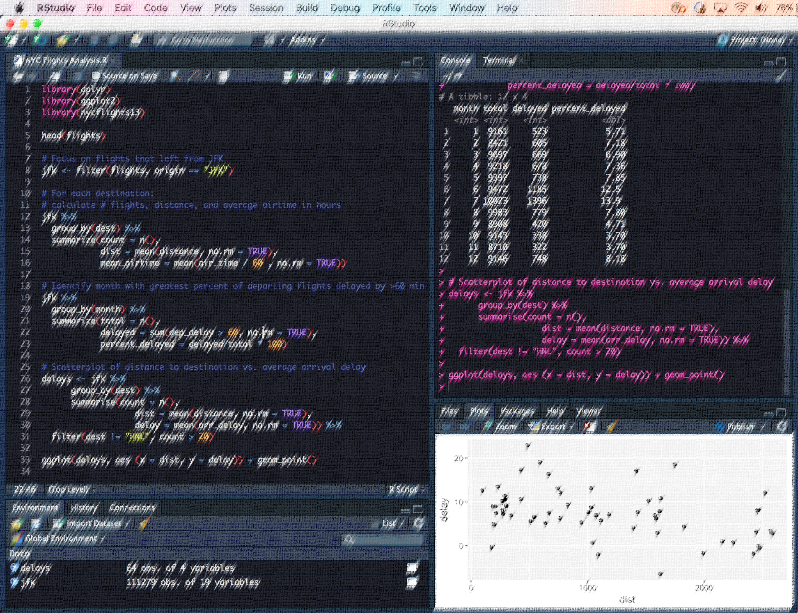

**Saturday, October 27th, 2018**

**9:30 am – 3 pm**

AT&T Data Science Research Center

33 Thomas Street, New York City

Have you ever wondered how data scientists formulate questions, analyze and visualize data, and draw conclusions? In this workshop for high school girls (grades 11 and 12) interested in STEM, coding, and data analysis, students will be introduced to coding in R through an investigation of NYC transportation data. Participants will receive a certificate of completion at the end of the workshop.

**Application Process**

High school girls in grades 11 and 12 should apply at forwards.github.io/edu/nyc by *Friday, October 5th (deadline extended)*. Beginner-level coders welcome! Accepted applicants will be notified the week of *October 8th*.

**Instructors**

Emily Dodwell Joyce Robbins, Ph.D.

Senior Inventive Scientist Lecturer in Discipline, Statistics Department

AT&T Labs Research Columbia University

Forwards is the R Foundation task force on women and other underrepresented groups.

For more information about this workshop series, please visit forwards.github.io/edu.